A2005-Eur-England-Kent-Northfleet-Aurignacian-Shell Bead-Early Upper Paleolithic-70,000 BP

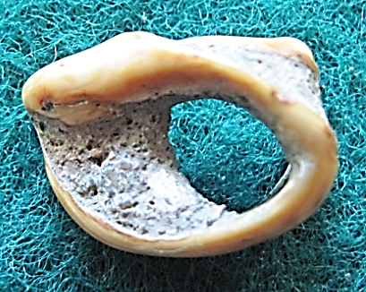 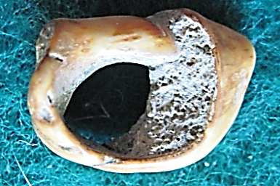

Figs. 1-2. England-Kent-Northfleet near Swanscombe-Aurignacian-Shell Bead-Early Upper Paleolithic, c 70 kya

**Accession Number: A2005**

**Formal Label:** England-Kent-Northfleet near Swanscombe-Aurignacian-Shell Bead-Early Upper Paleolithic, c 70 kya

**Display Description:**

Aurignacian shell-bead with orange ochre staining, found with other marine shell-beads in Kent-Northfleet near Swanscombe, England, dated to c 75,000 BP. Many of these artifacts disappeared by 60,000 BP, suggesting that modern human behavior had appeared before 60,000 BP and then was subsequently lost before becoming firmly established c 35,000 BP. It has been hypothesized that shell-beads communicated status to people in the “middle distance”, that is those who were not known to the wearer personally but who knew the meaning of the wearing of these personal ornaments. Two aspects are at play here. The shell made into a bead *constitutes* a form of symbolic meaning while the wearer *enacts* the meaning. Warren Coleman calls the shell-bead a constitutive symbol (Colman 2016:156-158):

The use of material objects in this way constitutes a transition from forms of cognition that are primarily directed to transforming the environment to those that are directed towards transforming human consciousness itself. This is because symbolic objects enabled humans to conceptualize themselves and their own ways of relating to each other.

The formulation of social facts via material symbols provided a basis for thinking about the *non*-material world and therefore facilitated consciousness, imagination, a sense of there being a spiritual dimension to the world. In this way, material objects function as elements of the extended mind that provide ‘surrogates’ for cognizing the immaterial [symbols]… .

This suggests that before symbols can be imagined things, they are *actual* things—physical objects … .

Or, to emphasize the material agency of things, we might say that the process of making beads from shells introduced a division of labor that was then symbolized by their use as objects of display.

Material objects of this kind are unlike the symbols of language in that they need to retain their concrete specificity in order to function as ‘surrogates.’

**LC Classification:** GN772.22.G7

**Date or Time Horizon:** 70 ky BP

**Geographical Area:** England-Kent-Northfleet near Swanscombe

**Geographical Area:** Northfleet near Swanscombe, Kent

**Map, GPS Coordinates:** 0.33694, 51.441072; 51° 26' 27.859" N 0° 20' 12.984" E.

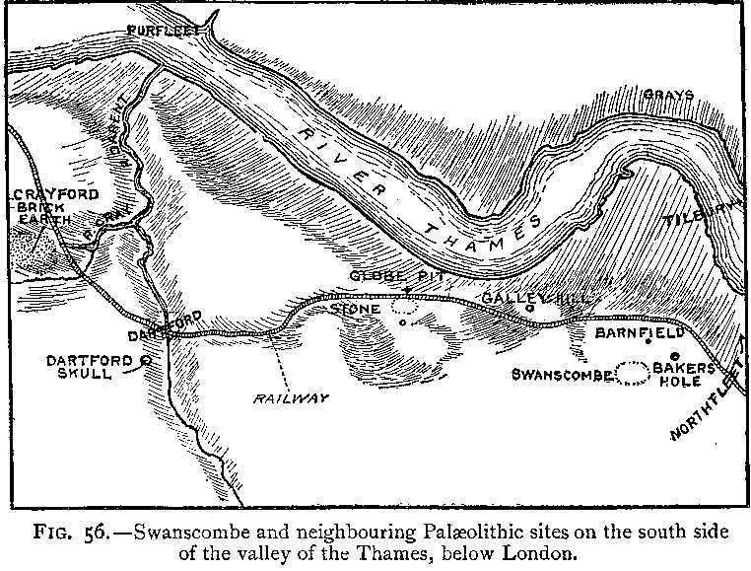

Fig.3. “Swanscombe and neighboring Paleolithic sites on the south side of the valley of the Thames, below London,” after Keith 1916, Fig. 56.

Fig. 4. Map of Swanscombe and Northfleet on the south side of the valley of the Thames, below London, up to 1996, where Paleolithic peoples sought flint in the chalk outcrops and areas of quarries. After [LinguisticDemographer](https://en.wikipedia.org/wiki/User:LinguisticDemographer) at [English Wikipedia](https://en.wikipedia.org/wiki/).

**Dimensions:** L 16.5 mm, .649 in

**Weight: 0.5 oz**

**Condition: original**

**Provenance:** Found in Northfleet, Kent, England, 2003, spoil from Channel Tunnel Rail Link (Springhead).

**Discussion:**

Shell beads like this one are among the earliest modern *homo sapiens* adornments yet found and were used in bracelets or necklaces. A key issue in human evolution is when modern symbolic imagination emerged. Human populations in England as well as in the Near East and South Africa had developed key cultural innovations by at least 80 kya. These innovations include systematic use of red ochre pigment for symbolic purposes for use as personal ornaments at coastal and inland sites in conjunction with complex lithic manufacturing and hafting techniques and refined pressure flaking and the use of backed lithics to produce composite tools that are considered by many as the earliest manifestations of “modern symbolic behavior.” Such innovations suggest a scenario that postulates a causal connection between the origin of homo sapiens in Africa ∼200 kya and their dispersal to Europe, the Near East and South Africa.

**References:**

Beaumont P (1980) On the age of the Border Cave hominids 1-5. *Palaeont Afr* 23:21–33.

Bird M, et al. (2003) Radiocarbon dating from 40 to 60 ka BP at Border Cave, South Africa. *Quat*

*Sci Rev* 22(8–9): 943–947.

Bronk Ramsey C (2009) Bayesian analysis of radiocarbon dates. *Radiocarbon* 51:337–360.

Conway, Bernard, John McNabb and Nick Ashton, eds.. 1996. *Excavations at Barnfield Pit,* *Swanscombe, 1968-72*; illustrations by Phil Dean. London: Dept. of Prehistoric and Romano-British Antiquities.

Keith, Arthur. 1915. *The Antiquity of Man*. London.

## McNabb, John. 2007. *The British Lower Palaeolithic: stones in contention*. London, New York: Routledge.

Miller G, et al. (1999) Earliest modern humans in southern Africa dated by isoleucine

epimerization in ostrich eggshell. *Quat Sci Rev* 18(13):1537–1548